Common Noun

🔹 What is Common Noun
# Source: AI Source: Provided by: [Data Path: Persons Table -> ID Column: 1, Name_En Column: Motasem Essam] -> From: [Chatgpt (GPT-4-turbo)] on [7/26/2025]
A common noun is a general name for any person, place, thing, or idea.
✨ It is not capitalized (unless it begins a sentence).

✅ Characteristics of Common Nouns:
# Source: AI Source: Provided by: [Data Path: Persons Table -> ID Column: 1, Name_En Column: Motasem Essam] -> From: [Chatgpt (GPT-4-turbo)] on [7/26/2025]
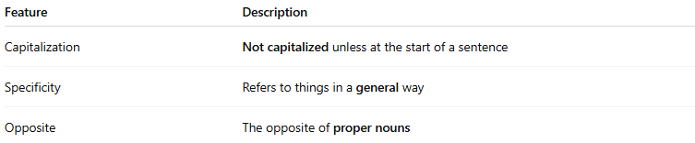
Feature | Description
Capitalization | Not capitalized unless at the start of a sentence
Specificity | Refers to things in a general way
Opposite | The opposite of proper nouns

🧠 Common Noun vs. Proper Noun:
# Source: AI Source: Provided by: [Data Path: Persons Table -> ID Column: 1, Name_En Column: Motasem Essam] -> From: [Chatgpt (GPT-4-turbo)] on [7/26/2025]
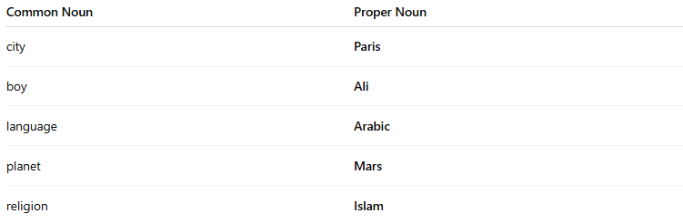
Common Noun | Proper Noun
city | Paris
boy | Ali
language | Arabic
planet | Mars
religion | Islam

📚 Categories of Common Nouns:
# Source: AI Source: Provided by: [Data Path: Persons Table -> ID Column: 1, Name_En Column: Motasem Essam] -> From: [Chatgpt (GPT-4-turbo)] on [7/26/2025]
- People
  - boy, girl, teacher, student, man, doctor
- Places
  - city, school, park, store, country
- Things
  - phone, chair, car, book, table
- Animals
  - cat, dog, lion, bird
- Ideas/Concepts
  - love, truth, freedom, fear

📝 Example Sentences:
# Source: AI Source: Provided by: [Data Path: Persons Table -> ID Column: 1, Name_En Column: Motasem Essam] -> From: [Chatgpt (GPT-4-turbo)] on [7/26/2025]
- The teacher gave us homework.
- I bought a new book from the store.
- A cat is sitting on the roof.

🟢 Tip to Remember:
# Source: AI Source: Provided by: [Data Path: Persons Table -> ID Column: 1, Name_En Column: Motasem Essam] -> From: [Chatgpt (GPT-4-turbo)] on [7/26/2025]
If the noun doesn’t name something specific, it’s probably a common noun.

Common Nouns vs. Proper Nouns
# Source: AI Source: Provided by: [Data Path: Persons Table -> ID Column: 1, Name_En Column: Motasem Essam] -> From: [Chatgpt (GPT-4-turbo)] on [7/26/2025]
Both common nouns and proper nouns are types of nouns — they name people, places, things, or ideas — but they serve different purposes in grammar.

🔹 1. Common Noun
# Source: AI Source: Provided by: [Data Path: Persons Table -> ID Column: 1, Name_En Column: Motasem Essam] -> From: [Chatgpt (GPT-4-turbo)] on [7/26/2025]
- General name for a person, place, thing, or idea.
- Not capitalized (unless at the beginning of a sentence).
Examples:
- teacher, city, river, religion, car, book

🔹 2. Proper Noun
# Source: AI Source: Provided by: [Data Path: Persons Table -> ID Column: 1, Name_En Column: Motasem Essam] -> From: [Chatgpt (GPT-4-turbo)] on [7/26/2025]
- Specific name of a particular person, place, thing, or idea.
- Always capitalized, no matter where it appears in a sentence.
Examples:
- Mr. Ali, Cairo, Nile River, Islam, Toyota, Quran

🧠 Key Differences:
# Source: AI Source: Provided by: [Data Path: Persons Table -> ID Column: 1, Name_En Column: Motasem Essam] -> From: [Chatgpt (GPT-4-turbo)] on [7/26/2025]
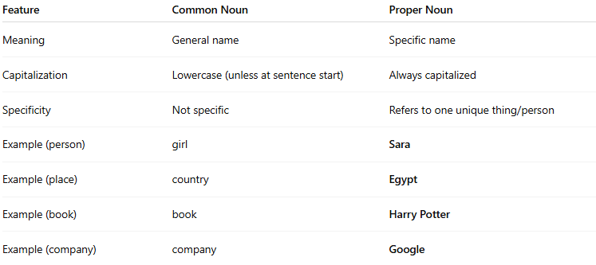
Feature | Common Noun | Proper Noun
Meaning | General name | Specific name
Capitalization | Lowercase (unless at sentence start) | Always capitalized
Specificity | Not specific | Refers to one unique thing/person
Example (person) | girl | Sara
Example (place) | country | Egypt
Example (book) | book | Harry Potter
Example (company) | company | Google

📝 Example Sentences:
# Source: AI Source: Provided by: [Data Path: Persons Table -> ID Column: 1, Name_En Column: Motasem Essam] -> From: [Chatgpt (GPT-4-turbo)] on [7/26/2025]
- I read a book. → (common noun)
I read Harry Potter. → (proper noun)
- She lives in a city.
She lives in Cairo.
- The teacher is kind.
Mr. Ahmed is kind.

✅ Summary:
# Source: AI Source: Provided by: [Data Path: Persons Table -> ID Column: 1, Name_En Column: Motasem Essam] -> From: [Chatgpt (GPT-4-turbo)] on [7/26/2025]
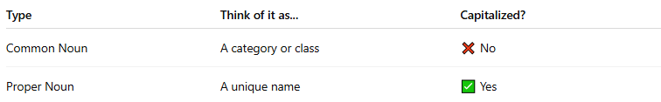
Type | Think of it as... | Capitalized?
Common Noun | A category or class | ❌ No
Proper Noun | A unique name | ✅ Yes

